# Abstract

# Problem Statement

The two-dimensional region between -pi and pi in the x and y coordinates is subject to boundary conditions and a forcing function. See the below image for the domain parameters.

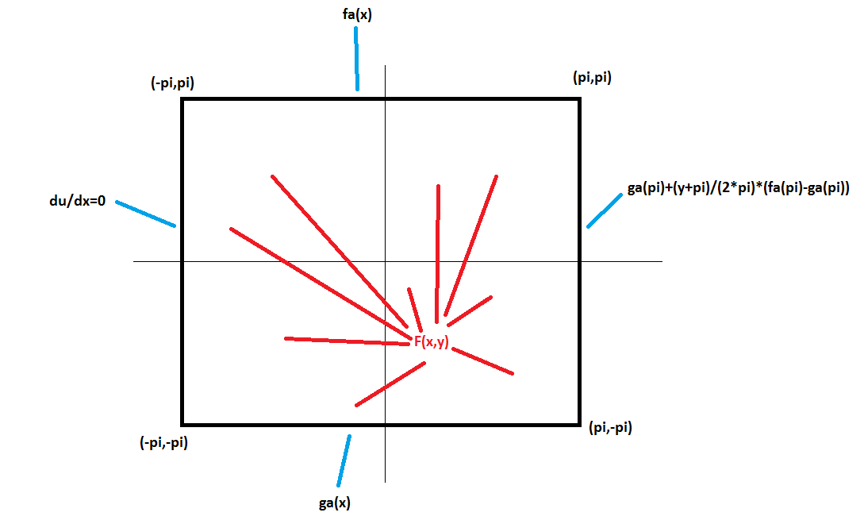

Figure Domain Setup

Where $g_{a}\left(x\right)={\left(x+pi\right)}^{2}*cos⁡(-x)$ and $f_{a}\left(x\right)=x*{\left(x+pi\right)}^{2}$

And the forcing function $F\left(x,y\right)=\sin\left(pi*\frac{x+pi}{2*pi}\right)*cos⁡(\left(\frac{pi}{2}\right)*\left(2*\frac{y+pi}{2*pi}+1\right))$.

The Poisson Equation is $\frac{d^{2}u}{dx^{2}}+\frac{d^{2}u}{dy^{2}}=-F(x,y)$.

# Descritized Equations

The Taylor series expansion is used to approximate the second derivatives as

$$\frac{d^{2}u}{dx^{2}}=(u_{i-1,j}-2*u_{i,j}+u_{i+1,j} )/∆x^{2}$$

And

$$\frac{d^{2}u}{dy^{2}}=(u_{i,j-1}-2*u_{i,j}+u_{i,j+1} )/∆y^{2}$$

For this problem, the step sizes in x and in y are kept the same for simplicity. So the Poisson equation can be approximated as:

$\frac{u_{i-1,j}-2*u_{i,j}+u_{i+1,j} }{h^{2}}$ + $\frac{u_{i,j-1}-2*u_{i,j}+u_{i,j+1} }{h^{2}}=-F(x,y)$

* $u_{i-1,j}-2*u_{i,j}+u_{i+1,j}$ + $u_{i,j-1}-2*u_{i,j}+u_{i,j+1}=-F\left(x,y\right)*h^{2}$
* $u_{i-1,j}-4*u_{i,j}+u_{i+1,j}$ + $u_{i,j-1}+u_{i,j+1}=-F\left(x,y\right)*h^{2}$

Solving for a node:

$u_{i,j}=F\left(x,y\right)*h^{2}+u_{i-1,j}+u_{i+1,j}+ u_{i,j-1}+u_{i,j+1}$

# Numerical Method

The numerical methods used to solve for u inside the domain are the Gauss-Seidel and Gauss Seidel with successive over relaxation. The nodes are solved for iteratively until the error between the previous solutions and the current solutions over the domain reaches 1%.

The nodes are solved for in an order that reduces the necessary number of iterations to convergence. The boundary conditions serve as known values of u. And nodes are solved for in the following order. The nodes along the boundary are solved first.

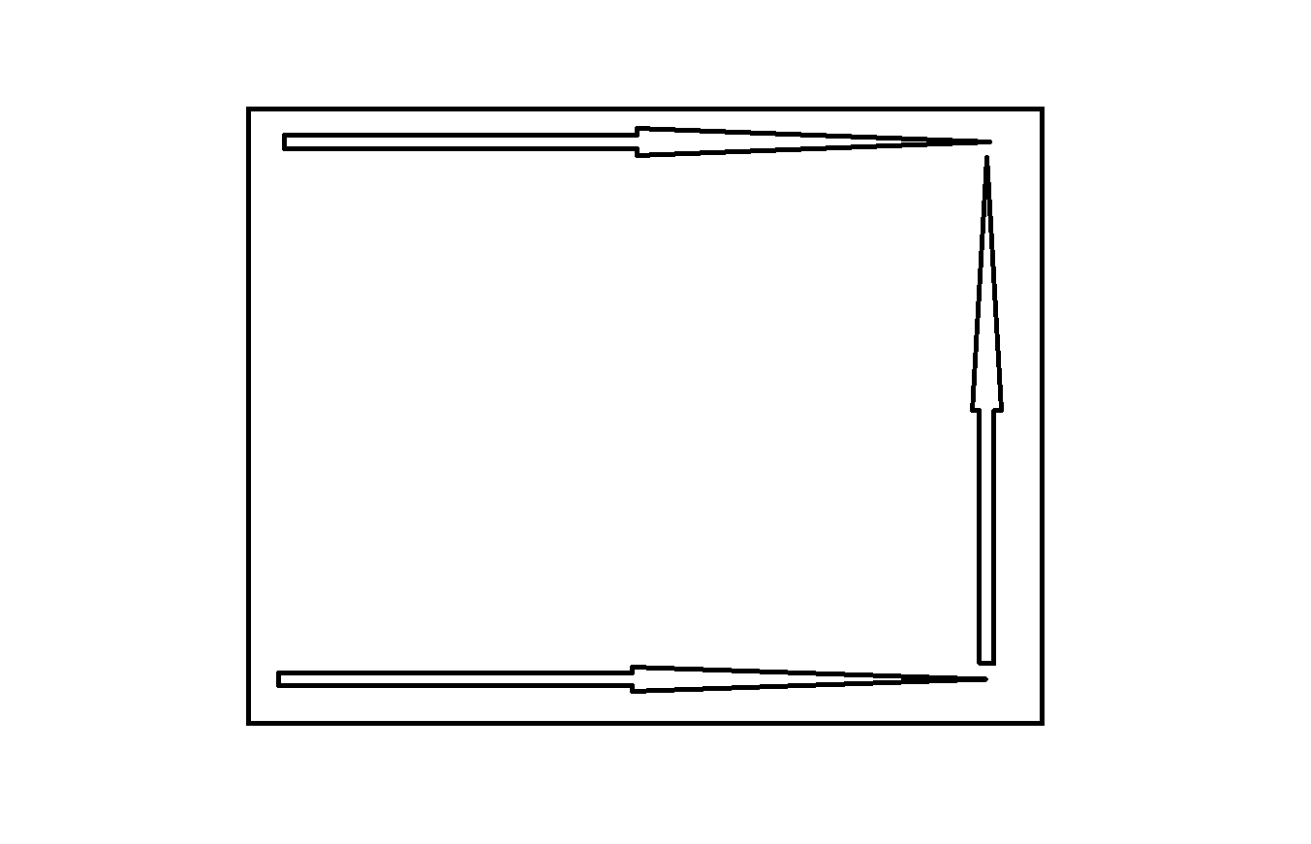

Then the nodes just solved for act as a new smaller boundary for the next nodes to be solved. This process is repeated until the triangular region near the Neumann condition remain.

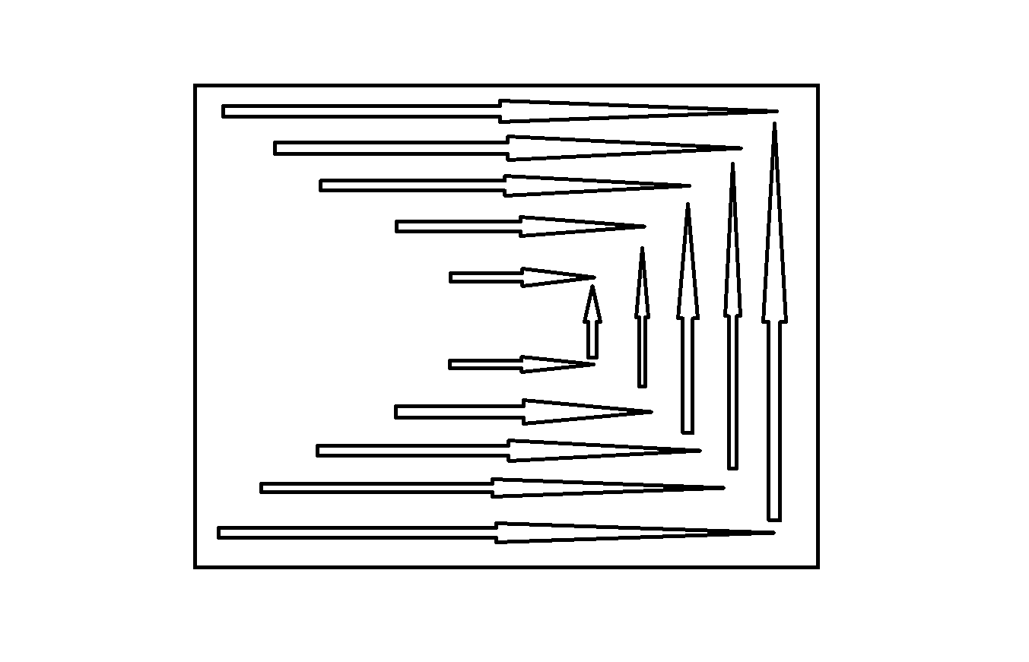

Then the nodes in the center of the domain are solved using the previously solved nodes. Starting at the inside and working toward the boundary.

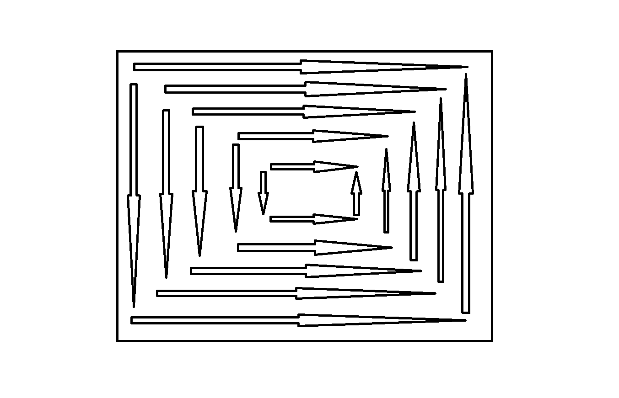

The nodes on the left side of the domain are copied across the boundary as ghost nodes, artificially simulating the Neuman condition.

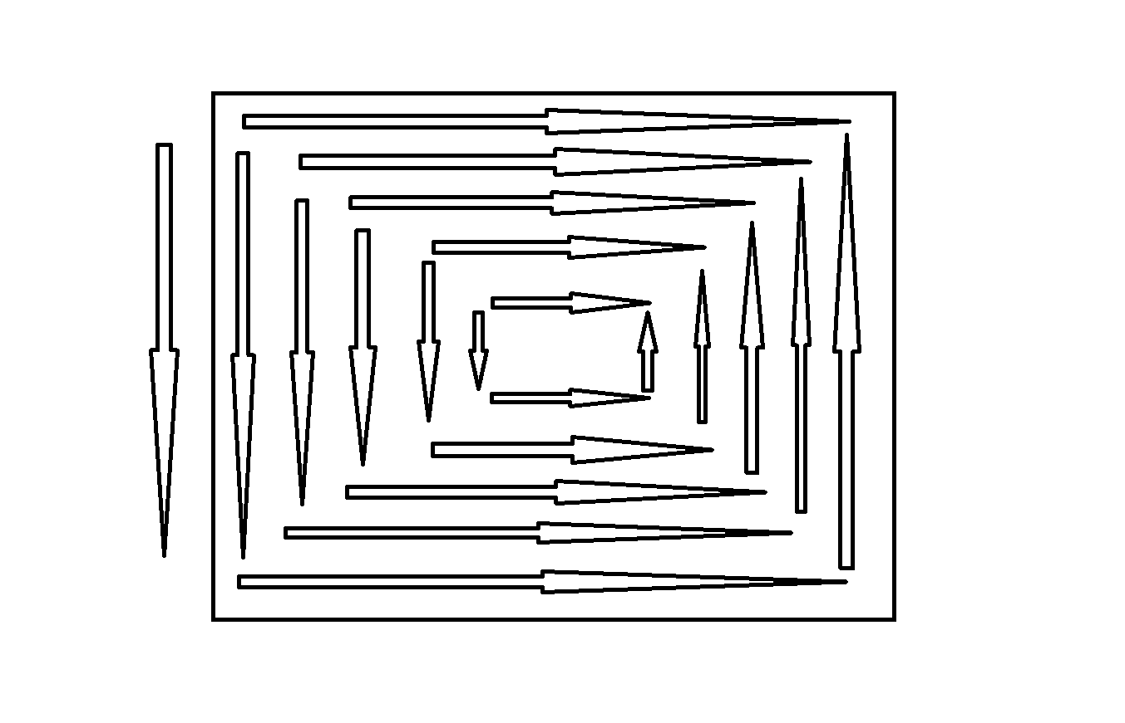

Finally, the nodes along the left boundary are solved and the first Gauss Seidel solution is complete. 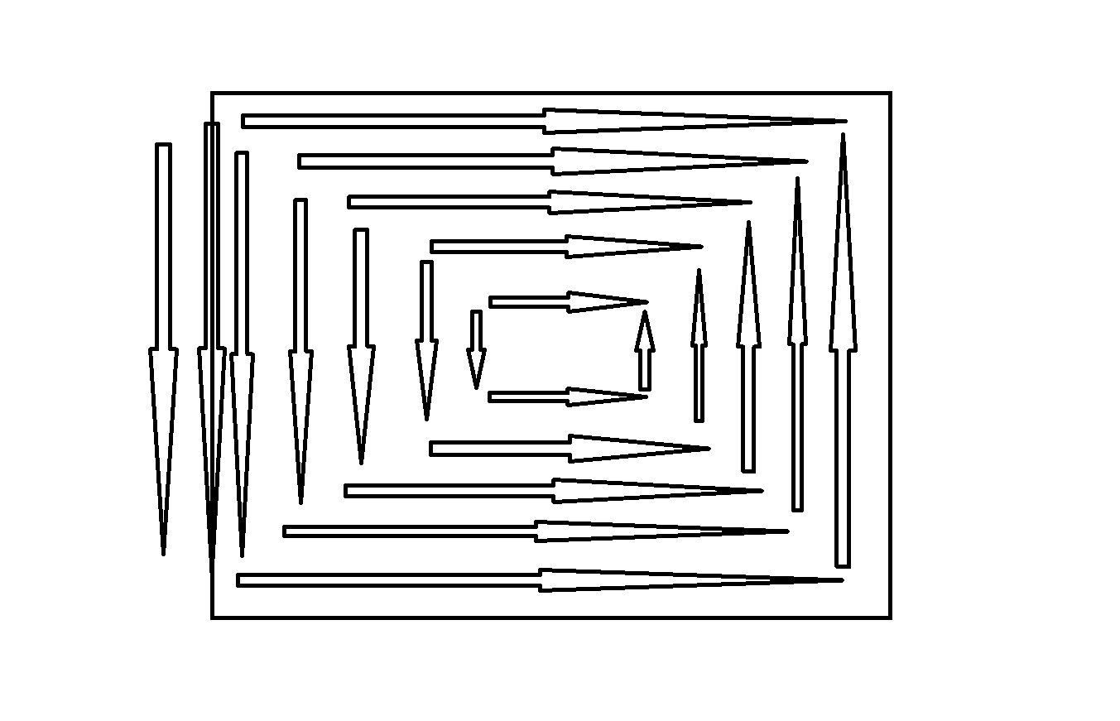

This process is repeated until the solutions converge to 1% discrepancy.

## Pseudo Code

Boundary conditions are set

% Top B.C.'s

for k=2:N+1

u(1,k)=x(k)*(x(k)+pi)^2;

end

% Bottom B.C.'s

for k=2:N+1

u(N,k)=(x(k)+pi)^2*cos(pi*x(k)/-pi);

end

% Right B.C.'s

for k=1:N

u(k,N+1)=((pi+pi)^2*cos(pi*pi/-pi))+...

((y(k)+pi)/(pi+pi))*...

(pi*(pi+pi)^2-...

((pi+pi)^2*cos(pi*pi/-pi)));

end

errorval=100;

iterations=0;

while errorval>1

iterations=iterations+1;

u_old=u;

% Circling

counter=2;

while counter<=N/2

Solving Nodes

% Top Pyramid

for j= N-counter+2 : -1 : counter+1

u( counter , j ) = ((sin(pi*(x(j)+pi)/(2*pi))*cos((pi/2)*(2*(y(counter)+pi)/(2*pi)+1)))*h^2+...

u(counter-1,j)+u(counter+1,j)+u(counter,j-1)+u(counter,j+1))/4;

end

% Bottom Pyramid

for j= N-counter+2 : -1 : counter+1

u( N-counter+1 , j ) = ((sin(pi*(x(j)+pi)/(2*pi))*cos((pi/2)*(2*(y(N-counter+1)+pi)/(2*pi)+1)))*h^2+...

u(N-counter+2,j)+u(N-counter,j)+u(N-counter+1,j-1)+u(N-counter+1,j+1))/4;

end

% Right Pyramid

for k= counter+1 : N-counter

u( k , N-counter+2 ) = ((sin(pi*(x(N-counter+2)+pi)/(2*pi))*cos((pi/2)*(2*(y(k)+pi)/(2*pi)+1)))*h^2+...

u(k-1,N-counter+2)+u(k+1,N-counter+2)+u(k,N-counter+1)+u(k,N-counter+3))/4;

end

counter=counter+1;

end

% Left Pyramid

counter2=0;

for j= floor(N/2)+1 : -1 : 3

counter2=counter2+1;

for k = floor(N/2)-counter2+2 : floor(N/2)+counter2-1

u( k , j) = ((sin(pi*(x(j)+pi)/(2*pi))*cos((pi/2)*(2*(y(k)+pi)/(2*pi)+1)))*h^2+...

u(k-1,j)+u(k+1,j)+u(k,j-1)+u(k,j+1))/4;

end

end

% ghost nodes

u(:,1)=u(:,3);

% left boundary nodes

for k=2:N-1

u(k,2)=((sin(pi*(x(2)+pi)/(2*pi))*cos((pi/2)*(2*(y(k)+pi)/(2*pi)+1)))*h^2+...

u(k-1,2)+u(k+1,2)+u(k,1)+u(k,3))/4;

end

for k=1:N

for j=1:N+1

error(k,j)=abs((u(k,j)-u_old(k,j))/u(k,j))*100;

end

end

% average error over domain

errorval=mean(mean(error));

end

# Computer Specifications

Operating System: Windows 7 Professional

Processor: Intel® Core™2 Duo CPU T9900 @ 3.06GHz 3.07GHz

Installed RAM: 4.00 GB

System Type: 64-bit

# Results

## Gauss Seidel Results

25 x 25 node solution:

Iterations to convergence: 130

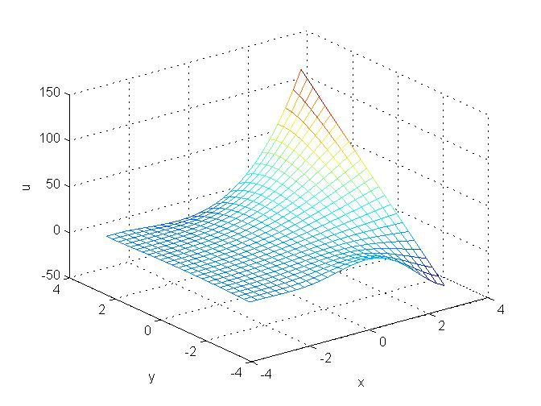

Figure Gauss Seidel 25 x 25

50 x 50 node solution:

Iterations to convergence: 183

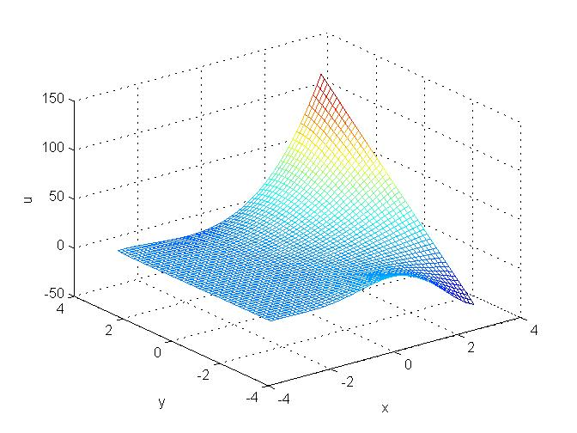

Figure Gauss Seidel 50 x 50

100 x 100 node solution:

Iterations to convergence: 205

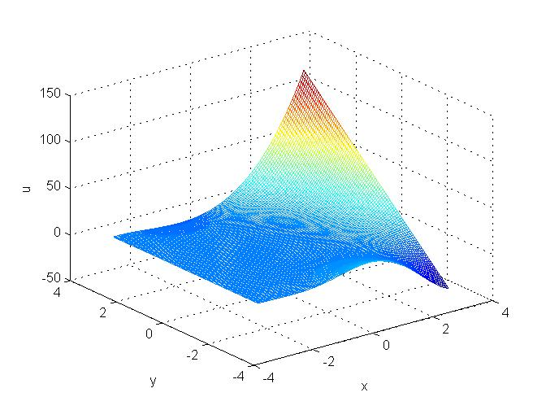

Figure Gauss Seidel 100 x 100

## Gauss Seidel Results with Relaxation

25 x 25 node solution:

Iterations to convergence: 93

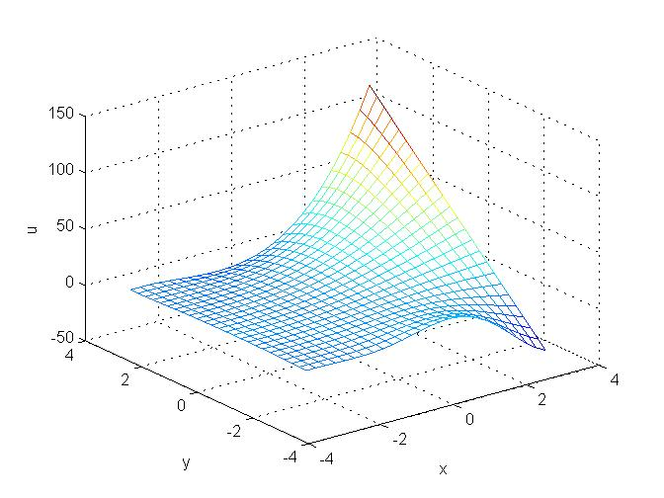

Figure Gauss Seidel 25 x 25 Relaxed

50 x 50 node solution:

Iterations to convergence: 131

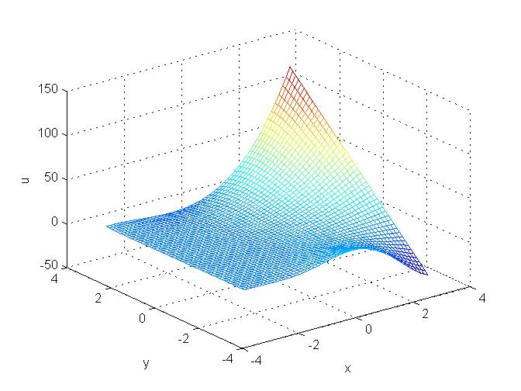

Figure Gauss Seidel 50 x 50 Relaxed

100 x 100 node solution:

Iterations to convergence: 147

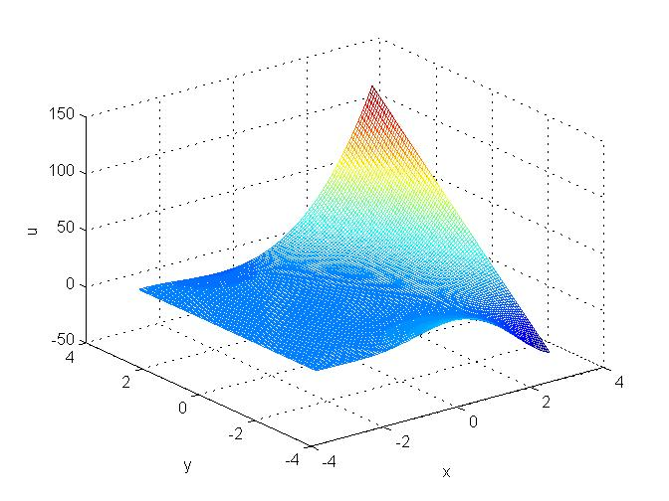

Figure Gauss Seidel 100 x 100 Relaxed

## Gauss Seidel No Forcing Results

25 x 25node solution:

Iterations to convergence: 116

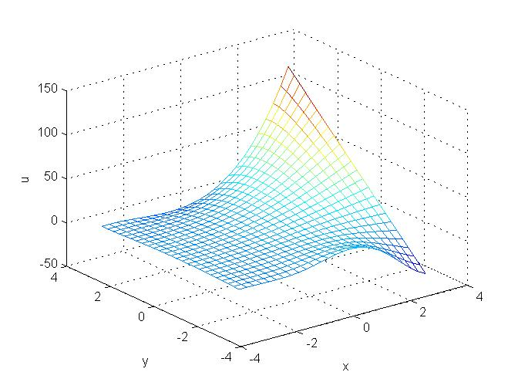

Figure Gauss Seidel 25 x 25 No Forcing

50 x 50 node solution: 229

Iterations to convergence:

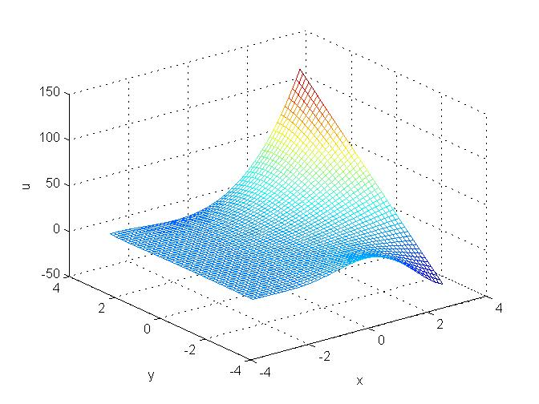

Figure 9 Gauss Seidel 50 x 50 No Forcing

100 x 100 node solution:

Iterations to convergence: 220

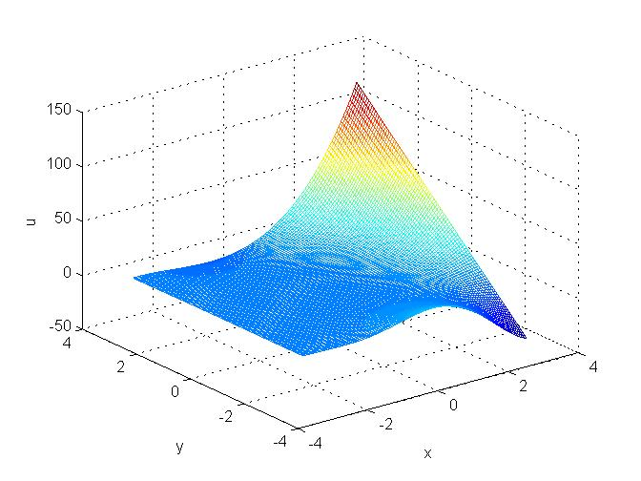

Figure Gauss Seidel 100 x 100 No Forcing